Lab sheet - 0 8 CIS 31042 - Practical for Data Mining

Topic: Hierarchical Clustering Algorithm

Aim: Working with Hierarchical Clustering Algorithm

Task: working with supplied test working with percentage split
working with hierarchical clustering

Exercise

- Import the telco data set into weka
- Visualize all the attribute
- Data prepossessing
- Cluster the data using Simple k mean algorithm (cluster mode: percentage split)
- Interpret the run information
- Cluster the data using Simple k mean algorithm supplied set test
- Load the glass.arff file into weka
- Normalized the attribute value
- Hierarchical cluster
- Explain the run information
- Visualized tree

- Import the telco data set into weka
- Open the weka software Click on Explorer then weka Explorer will open within that click on open file Go to the location of the dataset file Double click on that and open it.

- Visualize all the attribute
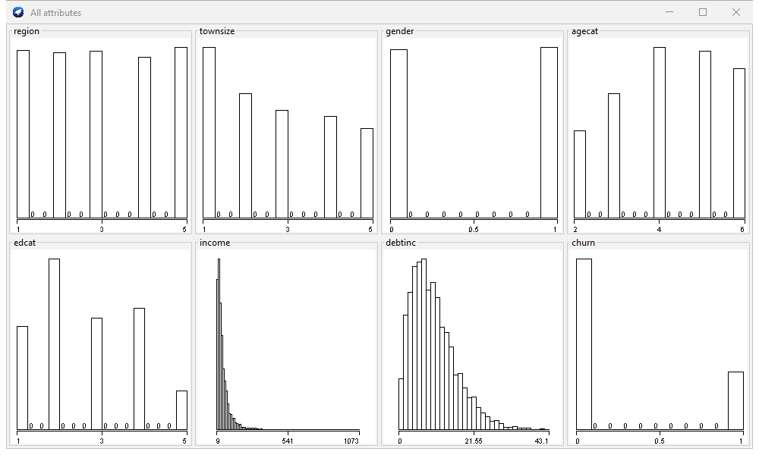

- Data prepossessing
- For the data preprocessing we need to remove the unwanted attributes here there is 3 unwanted attributes which is cusid / age /ed put the tick mark Infront of the relevant attributes and click on remove
- Here filling the missing values and discretizes done by automatically in clustering

- Cluster the data using Simple k mean algorithm (cluster mode: percentage split)

- Go to the cluster panel select the SimpleKMean algorithm within the choose option under the cluster give the bin as 2 and seed as 10 for simpleKMean algorithm Under the cluster model select the percentage split to enable it Click on start

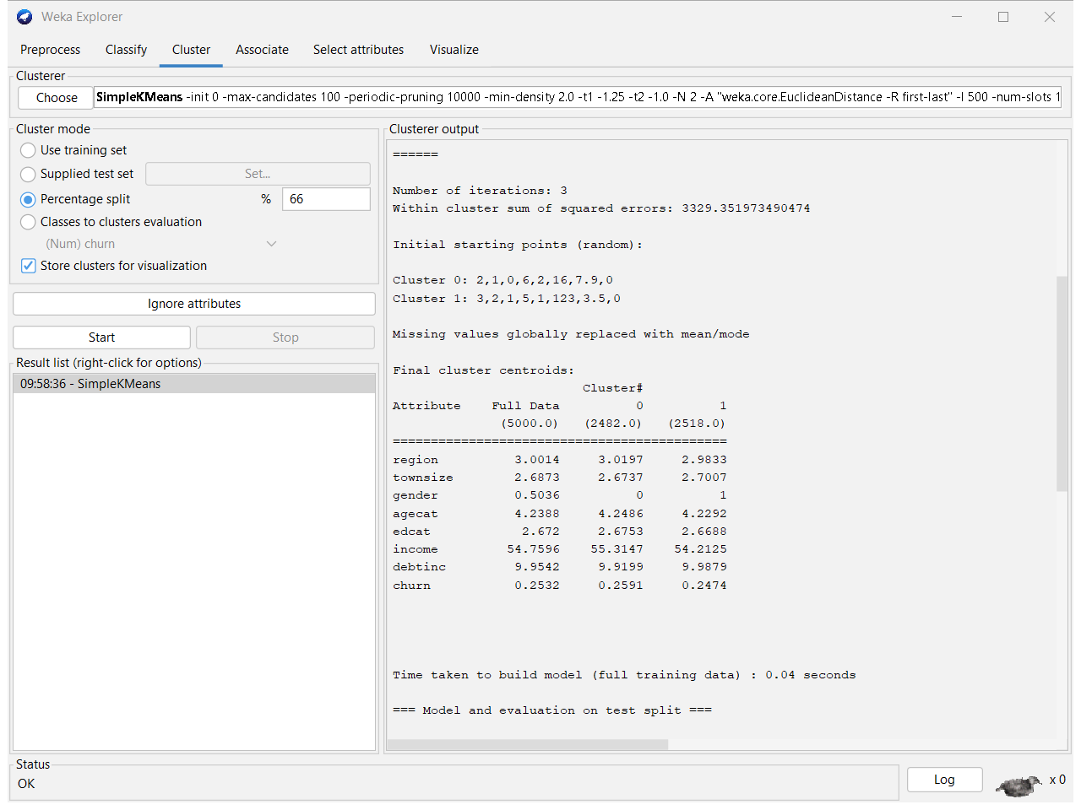
- Interpret the run information

- There are 5000 instances for the clustering purpose we use 8 attributes after preprocessing
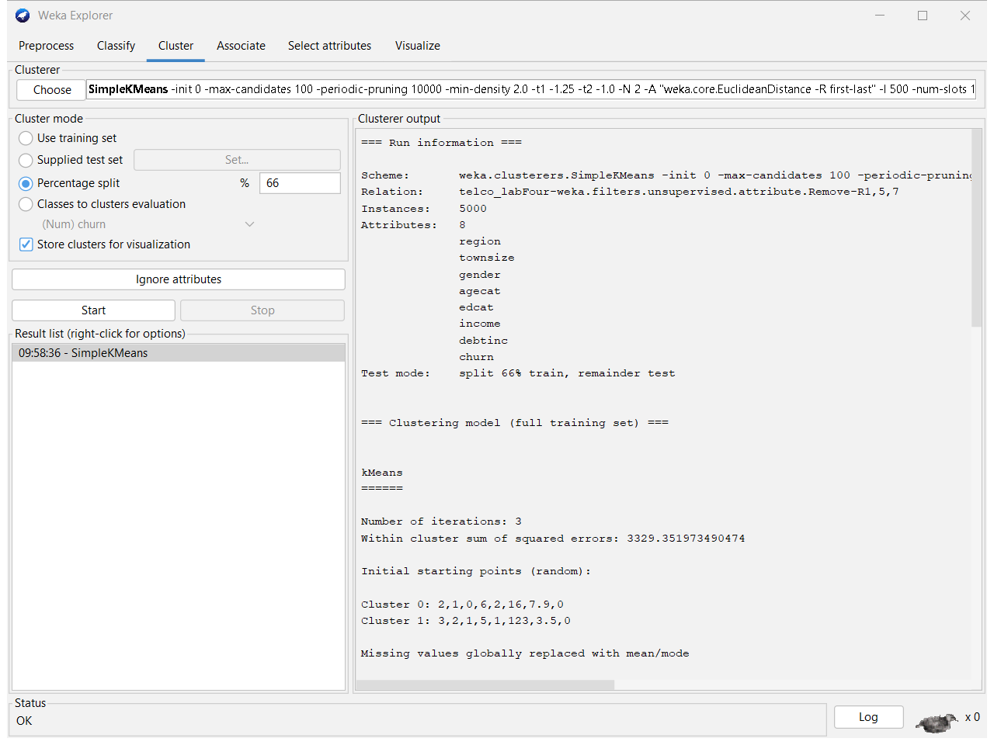

- For the kMean clustering there is 3 times iterated. While iteration 3329.3519734 number of sum of squared errors gain
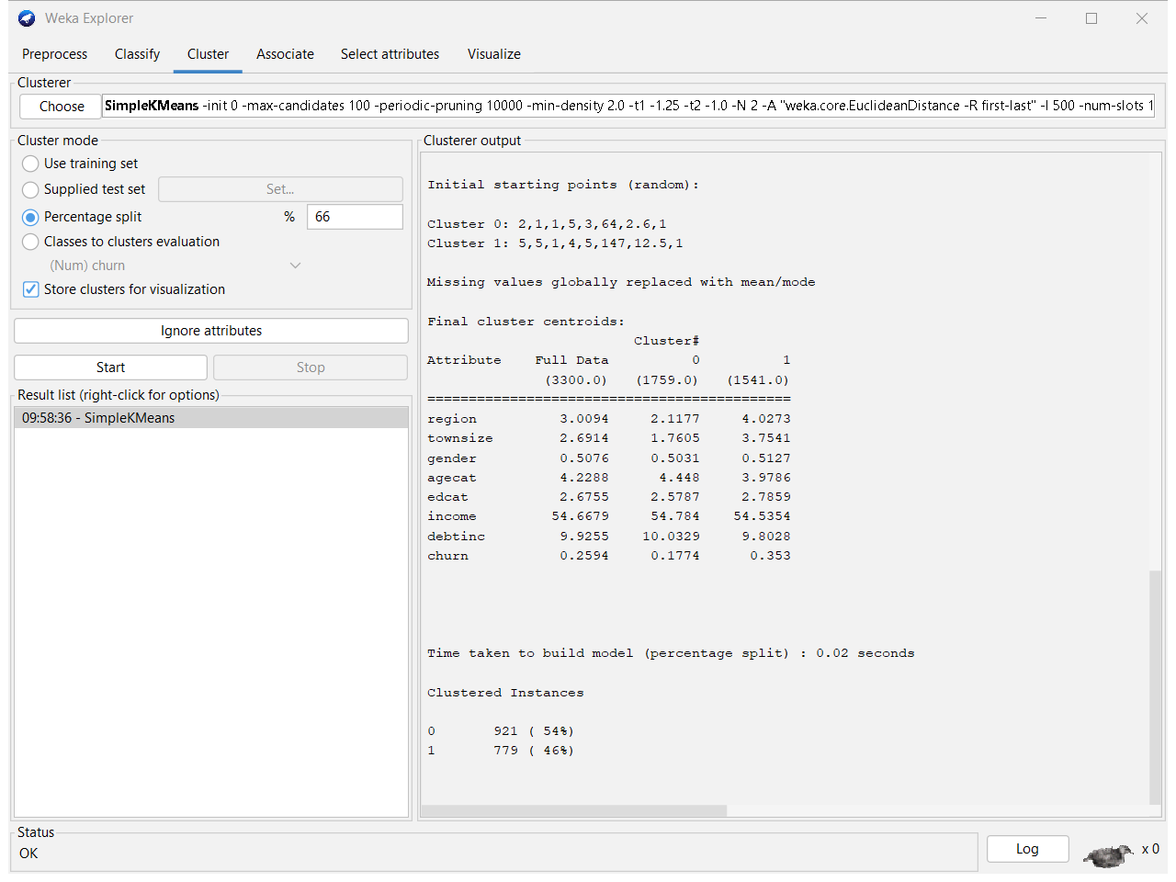
  - There is 3300 full dats is there within that 1795 data belongs to cluster 1 and 1541 data belongs to cluster 2
  - Above image show how to the clustering happened between cluster 1and 2 for given 8 attributes when considering the cluster instances for the cluster 1 there us 921 instances 54 % from all instances when considering the cluster 2 there us 779 instances 46 % from all instances

- Cluster the data using Simple k mean algorithm supplied set test
- First save the file with arrff file format Open it from Notepad ++ Keeping 8 attributes remove other all attributes Save the file go to the weka cluster panel Select cluster mode as supplied test set and click on set option and browns the file which we save with 8 instances click on ok
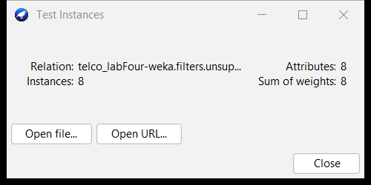

- Go to the result list right click on the previous result Click on reevaluate model on current test set
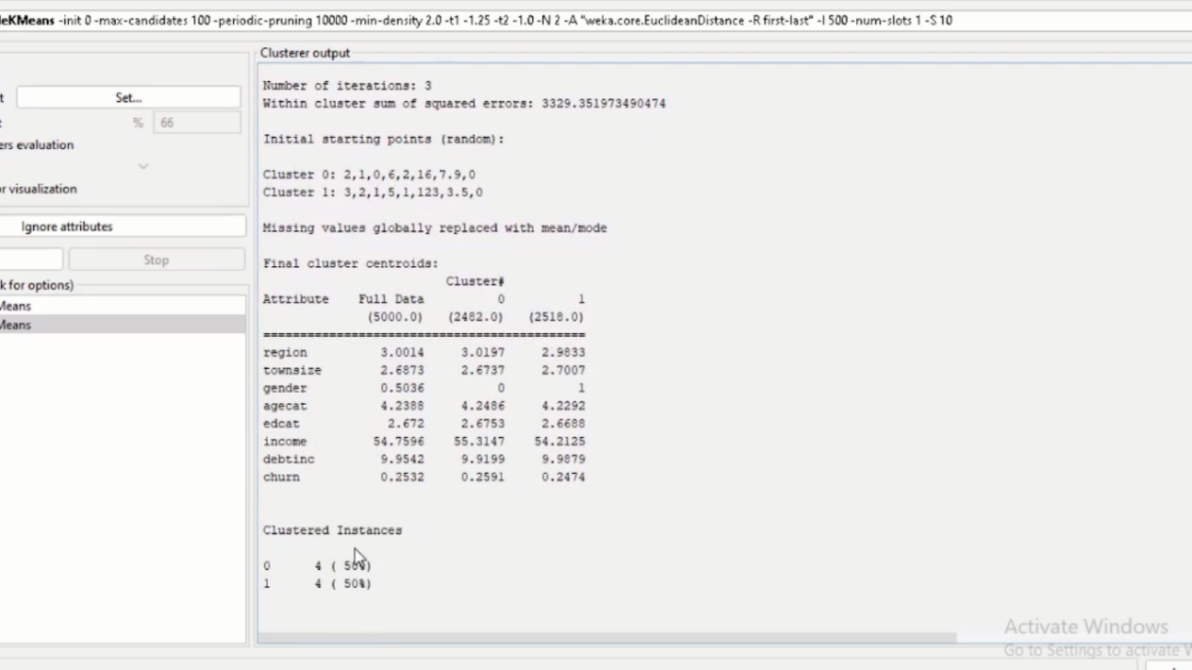

- Load the glass.arff file into weka
- Open the weka software Click on Explorer then weka Explorer will open within that click on open file Go to the location of the dataset file Double click on that and open it.

- Normalized the attribute value
- In the clustering we no need to normalized attributes in weka it automatically done

- Hierarchical cluster
- Go to the cluster panel Under the cluster select HierarchicalClusterer and make numCluster as 6 and click ok Click on start for clustering

- Explain the run information
- There are 214 instances and 10 attributes are available When considering the clustering model its show how the instance are clustered each cluster

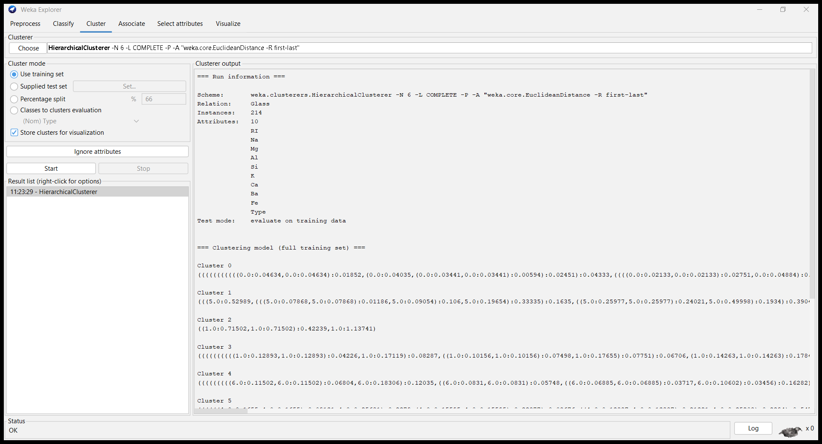

Here we can observe 5 clusters Appling hierarchicalCluster
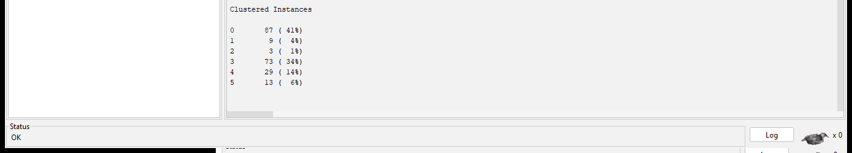

- Visualized tree

Right Click on the result which you want to generate visualized tree Click on Visualized tree
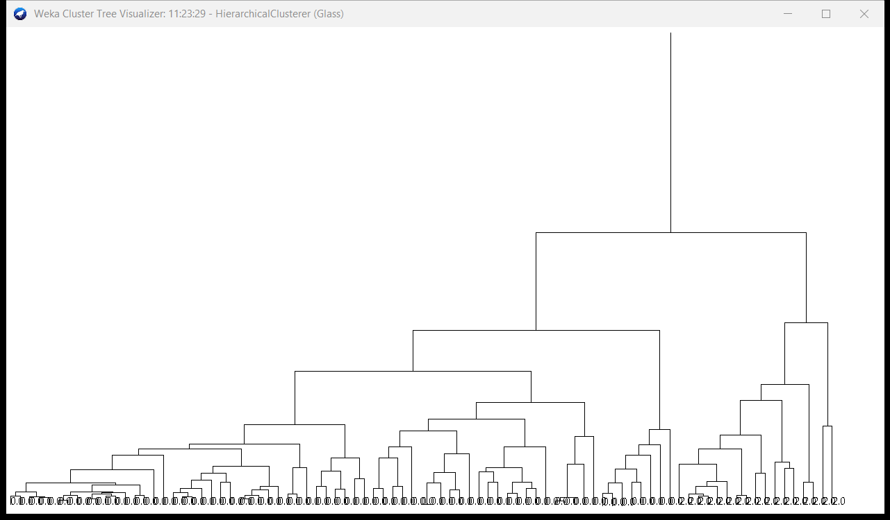

Discussion
Today in the practical session, we used Weka to look at clustering methods, focused on Simple K-Means and hierarchical clustering. First, we imported and preprocessed the telco dataset. Then, we used Simple K-Means in both percentage split and provided test set modes to look at the centers of the clusters and the SSE values. After importing and normalizing the glass dataset, we used hierarchical clustering to make a dendrogram and figure out how the data was structured in a hierarchy. We learned more about clustering methods and how to use them in data analysis through this activity.

